**Assessment 2**

**Certificate IV in IT-Programming**

**ICTWEB452 Create a markup  
language document**

## Task1- Define page structure

## Ramandeep Kaur- s14339800

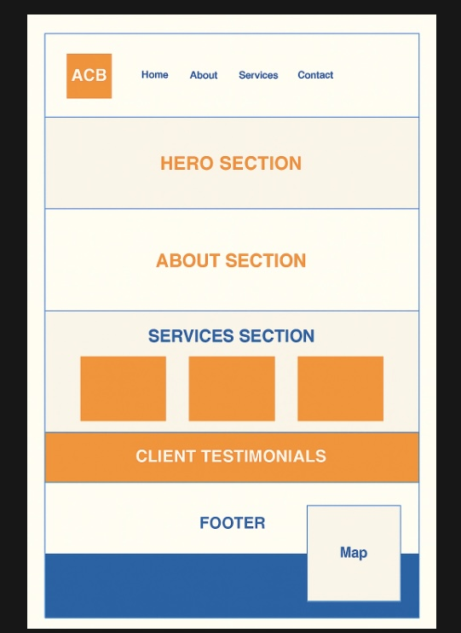

Page Structure Overview

1. Header

Logo (Left-aligned): "ACB" displayed within an orange square.

1. Navigation Menu (Positioned to the Right of the Logo):

Home

About

Services

Contact

1. Hero Section

A significant area designated for an introductory message, call-to-action, or banner image.

1. About Section

A concise summary or description outlining the purpose of the company or website.

Services Section

1. Features three horizontally aligned orange service boxes or icons.

Labeled as "SERVICES SECTION" in bold blue text.

1. Client Testimonials

A full-width section with an orange background, showcasing client feedback.

1. Footer

Includes:

Standard footer content (on the left side).

1. A Map box on the right side, indicating location or contact address.
2. Bottom Bar

A solid blue section, presumably for copyright, legal links, or branding.